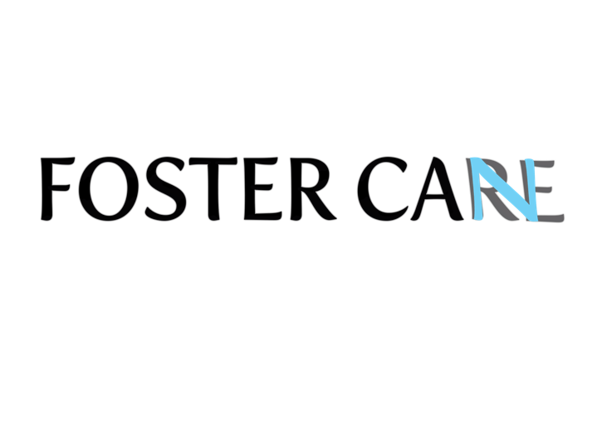

FOSTER CAN, INC.

BOARD OF DIRECTORS APPLICATION/SELF-NOMINATION FORM & PROFILE
Foster Can, Inc. seeks to promote diversity on our board. We encourage candidates to apply with diversity in human services, child welfare, public safety, behavioral health, mental health, advocacy, culture, ethnicity, race, gender, sexual orientation, disability, religion, region, population, and more.

Requirements for nomination:

18 years old

U.S Citizen or Permanent Resident

Name:
Birthdate:
Address:
City/State/Zip:
Phone
Email:
Picture: (please attach jpeg or similar quality)

The Foster Can, Inc. Board is a “working board” whose members play active and important roles in the success of the organization. To serve on the Board, members are required to:
- Attend and participate fully in board meetings, annual conferences, and other organizational functions and events.
- Understand and protect the fiduciary health of the organization.
- Understand and adhere to the democratic process of a non-profit board.
- Understand, promote, and be committed to Foster Can Inc.’s mission, vision, programs, policies, goals, and principles as set forth in our bylaws.

I hereby state the following statements are true:
- I am at least 18 years old.
- If elected, I agree to perform all duties required of Foster Can Inc. Board of Directors as outlined in the Foster Can, Inc. bylaws.
- I have no financial interests that would present a conflict of interest in serving on the Foster Can, Inc. Board. If such conflict should arise, I agree to excuse myself from any such discussion and vote, or resign if requested by the Board.
- I agree to uphold the mission, purpose, and public presence of Foster Can Inc., and to support the majority opinion of all Board actions.
- I agree to help with the financial growth and sustainability of the organization.

Signature of Applicant/Nominee (e-signature accepted):

__________________________________________________ Date: ______________________

FOSTER CAN, Inc. BOARD OF DIRECTORS NOMINATION BACKGROUND INFORMATION
Current Organization or Community Affiliation:

Please provide the following background information while adhering to the specified word limits. Please note that what is written below will appear on the ballot:
Affiliation: (Check and/all that apply)
____Former Youth in Foster Care (Age 30+)
____Community Advocate
____Foster Parent/Former Foster Parent
____Law Enforcement/ Criminal Justice/Attorney
____Financial/Community Development
____Non-Profit/Organizational Leadership and Administration
____Foster Care/Behavioral Health/Mental Health Provider
____Accounting/Financial Management/Grant Writing/Fundraising
____Other: Please specify:_______________________________________________________

Highest Level of Education Completed: Degree(s) in what field?
__High School __Some College __College Degree __ Masters __PhD/MD/JD/Doctorate
Field(s):

Current Employment/Experience: (200 word limit) Please identify all employment and/or volunteer experience that you believe will be helpful in your term on the Foster Can, Inc. Board.

Awards / Special Accomplishments (100 word limit)

Organization Memberships:(100 word limit)

QUESTIONS TO CANDIDATES

Please respond to the following four (4) questions in a total of 800-words or less:

  - Describe your involvement with your local and/or state community?

  - Describe how your values align with the mission of Foster Can Inc.

  - Describe the most valuable talent(s), skill(s) or relationship(s) you will bring to service on the Foster Can, Inc. Board?

  - What are some programming ideas you think could best serve Foster Can, Inc.’s targeted population?

APPLICATION DEADLINE: October 1, 2021

Please submit completed application, cover letter, and resume to info@fostercan.org

Once the review period ends, the Foster Can, Inc. Board will review all applications and contact nominees for interviews before the next election.

